**Brooklyn torah gazette**

**For parshas shemini 5783**

Volume 7, Issue 31 (Whole Number 338) 24 Nissan 5783/ April 15, 2023

**Printed L’illuy nishmas Nechama bas R’ Noach, a”h**

For a free subscription, please forward your request to [***keren18@juno.com***](mailto:keren18@juno.com)

**Truth is Not Negotiable**

**By Rabbi Abraham J Twerski, M.D.**

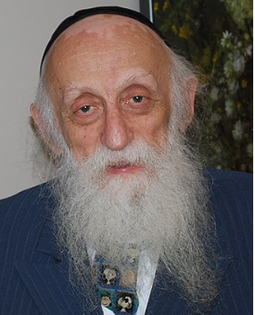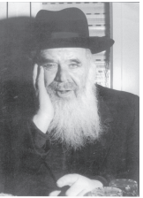

**Rabbi Abraham J Twerski and Rav Chaim Shmulevitz**

*Moshe heard and he approved* (10:20).

The Midrash says that when Aharon questioned Moshe’s instructions, saying that perhaps Hashem had not told him what Moshe claimed He did, Moshe said, “You are right. I forgot what I had heard from G-d.”

Rav Chaim Shmulevitz points out that Moshe was confronted with an awesome decision. Moshe was the sole conduit of the word of Hashem, and there was no way to verify his instructions.

If he were to admit that he had forgotten and had erred in conveying Hashem’s words, how would that impact on the authenticity of the entire Torah? Might people not say, “If Moshe could have erred in one thing, perhaps he erred in others as well”?

**Placing the Validity of the Entire Torah in Jeopardy**

Admitting that he had erred in this one instruction would place the validity of the entire Torah in jeopardy for eternity. Was this not adequate reason for Moshe to stand his ground and say, “Do as I said. That is Hashem’s wish”?

But Moshe knew that truth should never be compromised. He was obligated to speak the truth. Whatever consequences might flow from that was not his responsibility. Speaking falsehood cannot be justified. His responsibility was to adhere to the truth. The authenticity of Torah throughout eternity was Hashem’s responsibility, not his (Sichos Mussar 5731:11).

How often do we deviate from the truth for reasons far less momentous than that available to Moshe? Many people think that a “white lie” is exempt from the Torah prohibition against lying (Vayikra 19:11).

**One May Alter Things for the Sake of Peace**

The frequently quoted axiom that one may lie to restore peace is inaccurate. Rashi states that one “may alter things” for the sake of peace (Bereishis 18:13, 50:16), which means that one may say something which is not frankly untrue, but which can be interpreted in several ways.

The Talmud does not sanction outright falsehood for any reason. Even “altering things” is only permitted for the sake of restoring peace. Adhering to absolute truth is not always easy, but we have no option.

**A Crucial Element in Parenting**

Not only is truthfulness mandated by the Torah, but it is also crucial in parenting. Children cannot distinguish “white lies” from any other color. Parents who are not truthful are modeling lying for their children, and should not be surprised when their children lie to them.

We declare, “Moshe emes v’Soraso emes.” The truth of Torah is evidenced by Moshe’s refusal to deviate from the truth, regardless of the consequences. We should follow his example.

*Reprinted from the Parshas Shemini 5782 edition of At the ArtScroll Shabbos Table. Excerpted from the ArtScroll book Twerski On Chumash by Rabbi Abraham J. Twerski.*

**The Sound of Silence**

**By Rebbetzin Chaya Sora Gertzulin**

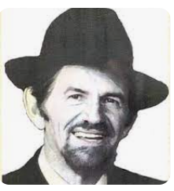

**Rabbi Meshuelem Halevi Jungreis**

“Vayehi bayom hashmini, and it was on the eighth day.” (Vayikra/Leviticus 9:1)The number seven connotes tevah, what is natural, as in the days of the week, while eight is le'ma'ala min ha'tevah — above and unconstrained by nature, entering the realm of the spiritual.

For a week, Moshe was busy consecrating the Mishkan, the Tabernacle. On Yom HaShemini, the eighth day, the Mishkan was inaugurated. A day of much anticipated joy and celebration. A day of attaining great spiritual heights.

For Aaron, the brother of Moshe and the Kohain Gadol, the High Priest, it evolved into a day of tragedy.

“Nadav and Avihu, sons of Aaron took their fire pans, and placed ketores, incense in them and offered them before HaShem. An alien fire that HaShem had not commanded. And a fire came forth from HaShem and consumed them. And they died before HaShem.” (Vayikra/Leviticus 10:1-2)

Nadav and Avihu erred by bringing an offering on their own. An aish zarah, a foreign fire. An offering that had not been requested by HaShem. There are numerous explanations as to why and how this could have happened. One is a teaching of Rabbi Levi Yitzchak of Berditchev (1740-1810). He explains that their death was not a divine punishment, but in their eagerness to serve HaShem, they crossed a boundary, endeavoring to enter a world in which they were unable to exist.

Nadav and Avihu saw their father prepare for the kehunah, the priesthood. A desire to come closer to HaShem was part of their very being. Yet, in their fervor to attain greater spiritual height, they did something they were not asked to do.

We can’t begin to comprehend the agony Aaron must have endured, losing two sons at the very same moment. What words of comfort and consolation could Moshe possibly offer to his beloved brother? With much compassion, Moshe approached Aaron, telling him that Nadav and Avihu perished while sanctifying HaShem’s name. He conveyed a message from HaShem: “B’krovai ekodesh, I will be sanctified by those who are closest to Me, v’al pnei kol ha’am ekovaid, thus, I will be honored before the entire nation.” (Vayikra/Leviticus 10:3)

Rashi comments that Moshe consoled Aaron with these beautiful words: “Aaron achi, my brother Aaron, I knew that the Mishkan would be sanctified by those beloved by HaShem. I thought it would be either you or me. Now I know that they (Nadav and Avihu) were greater than either of us.”

**Vayidom Aaron, and Aaron was silent.**

How do we understand Aaron’s reaction?

One of the great Torah commentators, the Malbim (1809-1879) explains that the word vayidom, and he was silent, is not commonly used to describe silence. It is used when one becomes quiet in the midst of speaking. While Aaron was expressing his emotions on his tragic loss, Moshe spoke, and Aaron said nothing further.

Upon comforting one who is mourning, it is customary not to initiate conversation, but to allow the mourner to take the lead. Aaron began speaking, and Moshe responded with words of comfort.

Vayidom Aaron. Aaron stopped speaking and accepted Moshe’s words of consolation.

Vayidom has the same root as the Hebrew word domeim, meaning inanimate objects such as stones, rocks and mountains.

**Strong as a Mountain**

Aaron’s reaction was to be resilient, like a rock. After hearing Moshe’s words, he became strong as a mountain. Unshakable and steadfast.

Vayidom – he was silent. Not a silence of anger or bitterness. Nor a silence of despair and depression. Aaron’s silence reflected his emunah and bitachon, his faith and trust in HaShem. Even though the pain was devastating, Aaron’s silence expressed his conviction that HaShem was with him, at all times and through all circumstances. His silence spoke volumes. Aaron was ready to be strong and continue his holy work as the Kohain Gadol.

Life comes with its challenges. Times when we may feel like asking, why me. The

Torah teaches us that it’s not about the “why”. Though there may not always be answers as to why, what is vital is to have faith to carry on. That is the essence of a Jew.

It started out as a beautiful fall day. My father, HaRav Meshulem ben HaRav Osher Anshil HaLevi zt”l, went to see a doctor for some stomach pain, expecting a routine exam. But it was anything but routine. My Abba was informed that he was facing a diagnosis of cancer.

Vayidom. My father mustered up his inner reserves of strength, and accepted the doctor’s words with unwavering trust in HaShem. The doctor later shared with our family how “the Rabbi brought tears to my eyes, when he said that he was sorry that I had to relay a difficult diagnosis”.

Vayidom. The day was not over. Without saying a word, or exhibiting any outward sign of pain, my father continued on with his schedule. He went from the doctor’s office to my sister Slovie’s home, to be a loving zeide and study Torah with his grandson.

It was only later in the day that Abba shared the news with our family.  
The strength of silence. The power of vayidom.

*Reprinted from the Parshat Shemini 5782 edition of the TorahAnytime.com Newsletter.* Compiled and Edited by Elan Perchik.

**Thoughts that Count**

**Our Parsha**

They brought what Moses commanded before the Tabernacle of Meeting, and all the congregation drew near and stood before G-d (Lev. 9:5)

According to the Kabbalist Rabbi Yitzchak Luria, the commandment to love one’s fellow Jew must be accepted before beginning to pray. Only when “the congregation drew near” to each other in love and unity, did the Jewish people “stand before G-d” in prayer and supplication. (Chesed L’Avraham)

The Torah portion of Shemini begins with the most sublime and elevated service on the eighth day of preparation for the Tabernacle, and ends with the prohibition against eating crawling insects, something which goes against human nature. From this we learn that even one who stands on the highest level of spirituality and observance is not protected against spiritual downfall, G-d forbid, and must serve G-d with the same measure of acceptance of the yoke of heaven as others. (Likutei Sichot)

**The Significance of the Eighth**

**From the Teachings of the Lubavitcher Rebbe**

**Rabbi Menachem Mendel Schneerson, Zt”l**

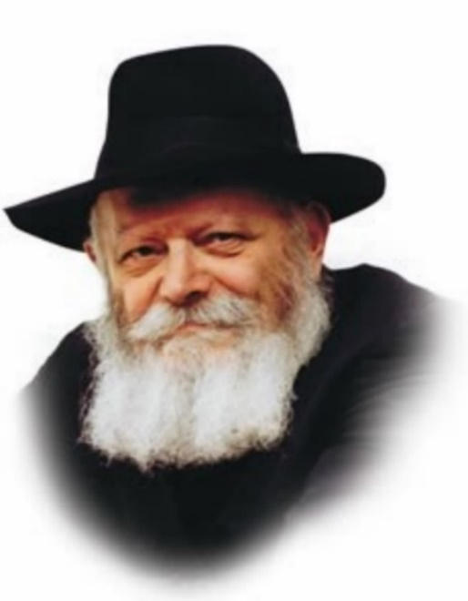

This week’s Torah portion is called Shemini, the “Eighth,” which refers to the day after the seven days of training the Kohanim (priests) underwent before the inauguration of the Sanctuary in the desert. Until the eighth day, G-d’s presence did not fill the Sanctuary, the G-dly fire didn’t descend onto the altar.

On the eighth day, following the seven days of their inauguration, Aaron and his sons begin to officiate as Kohanim; a fire came forth, consumed the offerings on the altar, and the Divine presence dwelled in the Sanctuary.

The portion continues by describing the “strange fire before G-d, which He commanded them not” that was brought by Aaron’s sons and the sons’ subsequent deaths. We also read of the identifying features or kosher animals and fish, and a list of kosher birds and insects. Lastly, there are laws of ritual purity, including the purifying power of a mikva and wellspring.

Back to the concept of eighth, the name of our portion: What is it about the “eighth” that makes all the difference?

In nature we find seven to be common. You have seven days of the week, seven years to our agricultural cycle. Kabbala teaches that there are seven building blocks of creation, which is six emotional attributes and the seventh, malchut, which amplifies these attributes, and they are directly connected to the six days of the week, and Shabbat.

We also find that music has seven notes - A through G. We even are told that King David had a harp that had seven strings.

All these sevens are meant to bring to the “Eighth.”

What is the “Eighth?”

The “Eighth” is our true essence, it is our ability to transcend nature and connect with the part of ourselves that is above nature, our neshama, our soul. The neshama is a part of G-d, and when we rise above nature we feel our essential bond with Him.

The seven days of training, brought them to the Eighth day, on which G-d’s presence reentered the Jewish community. This is because we once again found our way above our physical selves and revealed our oneness with G-d.

We work all week for Shabbat and if we utilize Shabbat correctly it will bring us to the next level.

Reprinted from the Parshat Shemini 5782 edition of L’Chaim, a publication of the Lubavitch Youth Organization in Brooklyn, NY. Adapted by Rabbi Yitzi Hurwitz from the teachings of the Rebbe, yitzihurwitz.blogspot.com. Rabbi Hurwitz, who is battling ALS, and his wife Dina, are emissaries of the Rebbe in Temecula, CA.

**Cure Yourself First**

*Come near to the Altar, and perform the service of your sin-offering and your elevation-offering, and provide atonement for yourself.* (9:7)

The Chatas, sin-offering, which Aharon HaKohen brought, was personal. It atoned for his participation in the chet ha’eigal, Golden Calf debacle. Why was it necessary for Aharon to offer up his korban prior to offering up the communal offering?

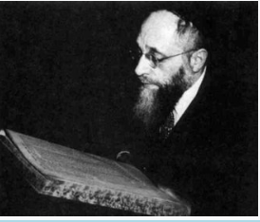

**Horav Eliyahu Meir Bloch, zl,**

Horav Eliyahu Meir Bloch, zl, derives from here that, prior to teaching others, one must first and foremost show that he himself is free of any such taint. When one seeks to convey his hashkafos, perspectives/outlook on life (based upon the Torah) to others, he must first be an exemplar of his teaching. K’shot atzmecha v’achar kach k’shot acheirim, “Beautify yourself first and (only) then attempt to beautify others.”

Simply, this Chazal (Sanhedrin18a) teaches that one should reflect on his own actions and self-evaluate prior to having the presumption to criticize others. Horav S. R. Hirsch, zl, explains that the first time the word k’shotis used, it is related to the Aramaic word kushta, which means “truth.”

**Be Truthful with Yourself**

In other words, Chazal are being frank with us. Be truthful with yourself – do not delude yourself that you are perfect – before you have the temerity to rebuke others. First of all, it is improper. Second, it will be ineffective.

No one wants to be criticized by a chameleon who expediently changes to please others to further his own goals. Thus, Aharon publicly addressed his own “failing” before he sought forgiveness from the nation.

Horav Naftali Amsterdam, zl, was one of the primary students of Horav Yisrael Salanter, zl. His erudition and righteousness notwithstanding, he made every attempt to conceal his greatness and his role in his saintly Rebbe’s mussar movement. Out of fear that his service to Hashem would become a source of false pride, he was self-effacing even in his private life.

He obstinately refused to accept any service from others, and he vehemently demurred from entering the field of rabbanus. He earned his meagre livelihood as a baker, whose products his wife sold in their little bakery. Sadly, his returns were less than satisfactory. When his daughter reached marriageable age, he was unable to provide for her dowry. In the end, he took a rabbinic position, followed by becoming a dayan in Petersburg –a position he held until he earned enough money to cover his payables.

**A Living Volume of Mussar**

He then returned to full-time learning. Rav Naftali neither had to teach his students mussar, ethical character development, from a book, nor lecture to them from a lectern, because he himself was a living volume of mussar. He embodied the highest ideals of mussar.

It is related that one week the holy Chafetz Chaim cancelled his weekly shmuess, ethical discourse. At the appointed time, he ascended to the lectern and said, “Kinderlach, my children, today I am unable to offer words of mussar. I can neither arouse your emotions nor inspire you, because this week I received copies of the Mishnah Berurah (his magnum opus), and I was compelled to spend long hours reviewing and editing each volume for errors. I would hate to sell a volume that had mistakes. This would be tantamount to stealing. I cannot demand diligence in Torah study when I myself have been lax in my commitment.”

*Reprinted from the Parshas Shemini 5783 edition of Rabbi A.L.Scheinbaum’s Peninim on the Torah*